LACUATA, Ara Belle P.

2ECE-C

**Problem 1**

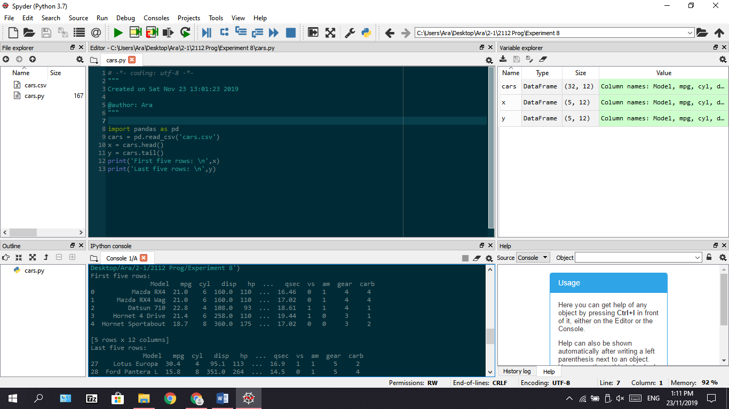

1. **Load csv**

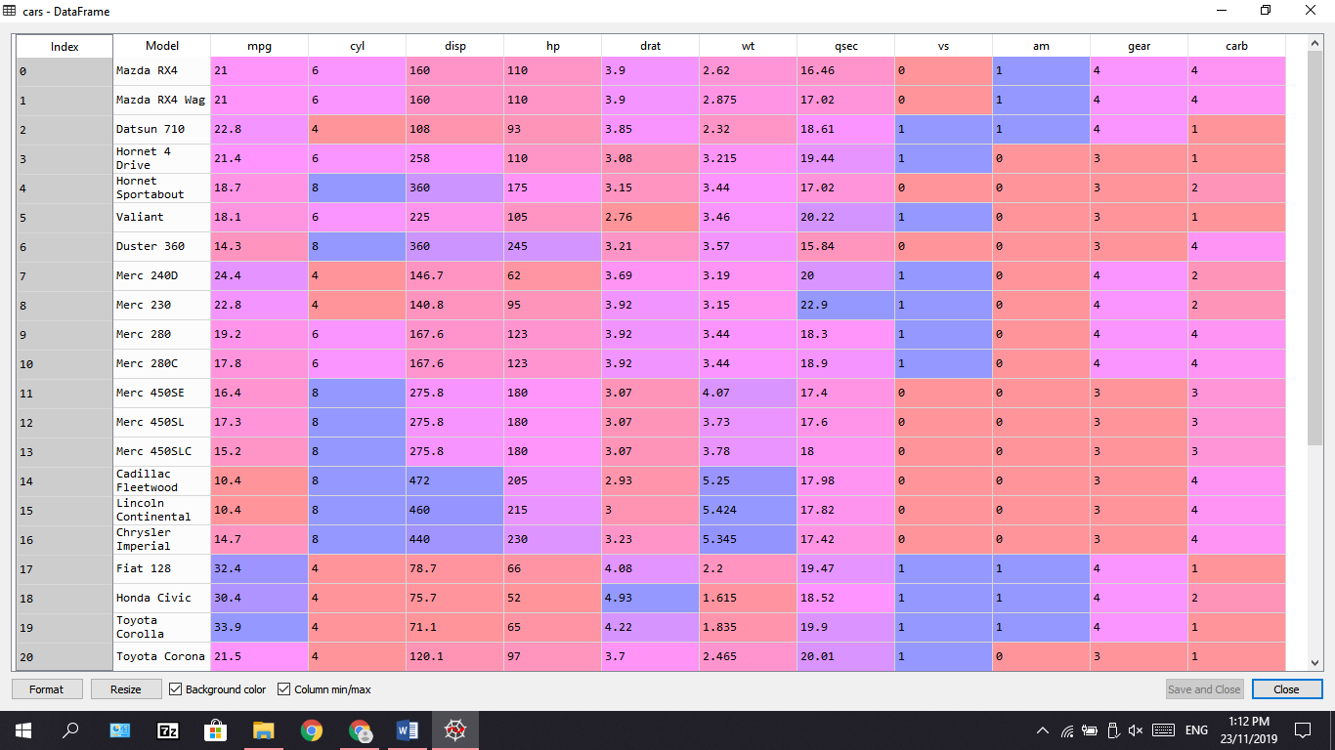

1. **Display first and last five rows**

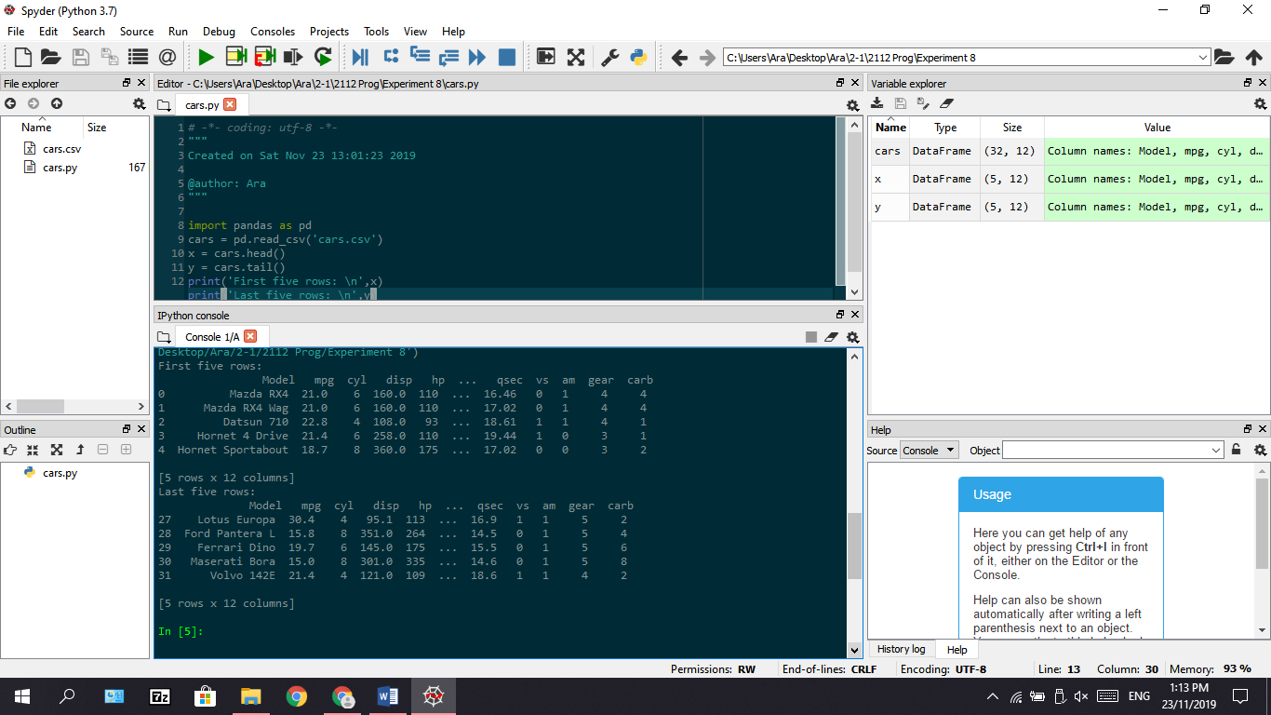

**Problem 2**

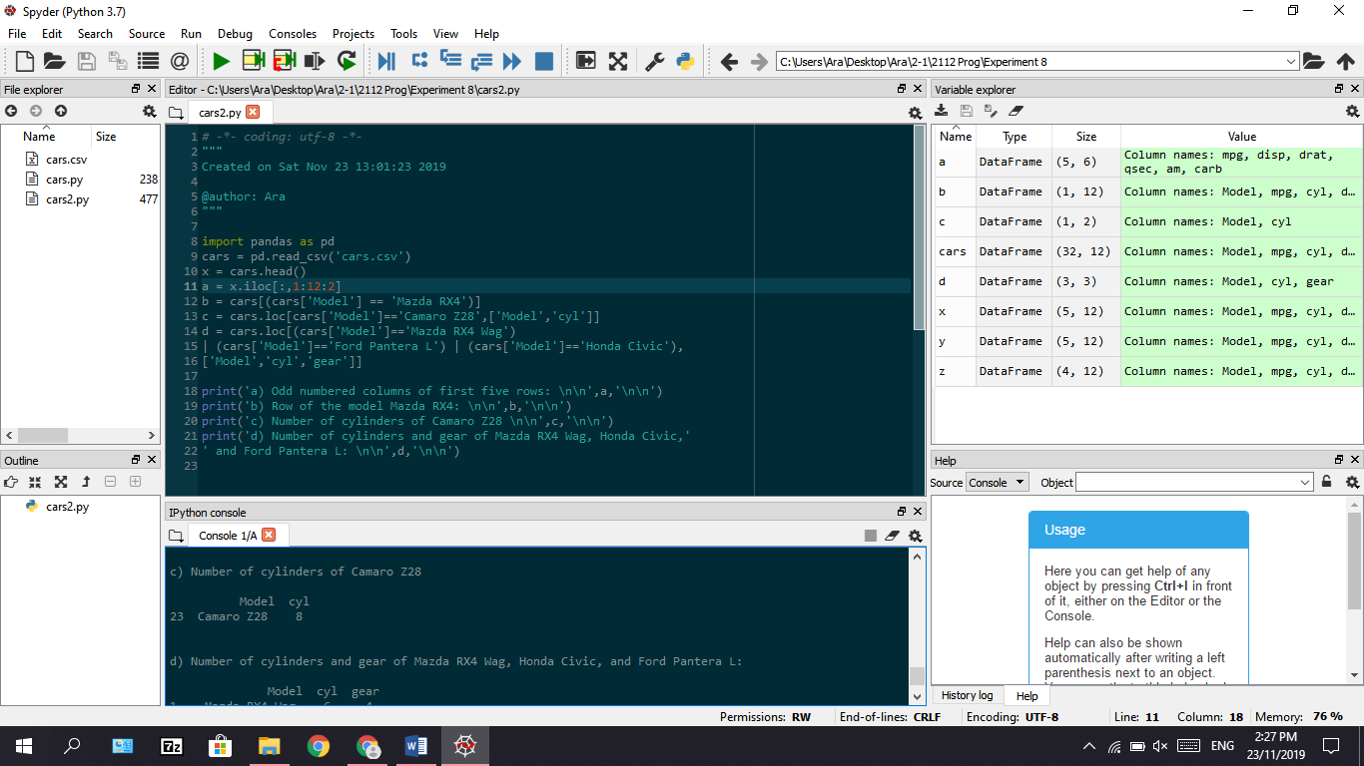

1. **First five rows with odd numbered columns**

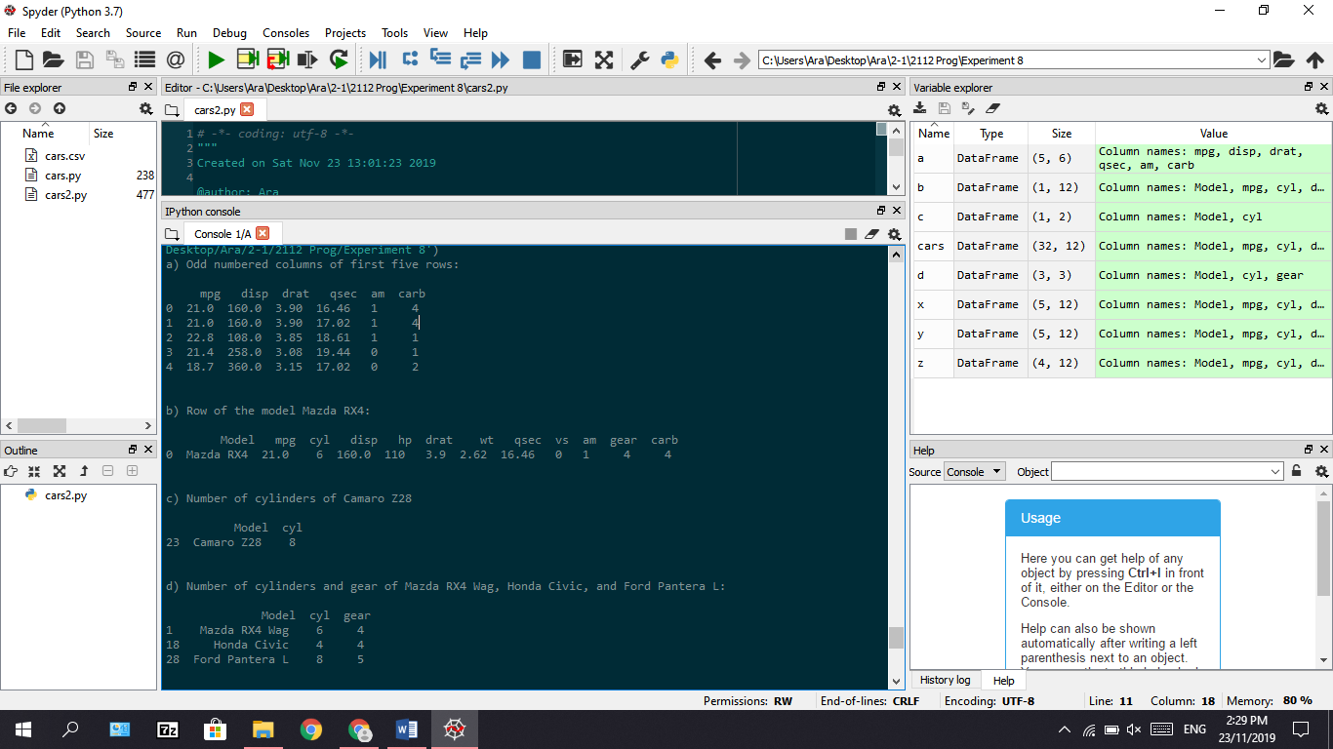

1. **Row that contains Model of Mazda RX4**



1. **Cylinders of Camaro Z28**



1. **Cylinders and gear type of Mazda RX4 Wag, Ford Pantera L and Honda Civic**

